This document follows the recommended framework for overview, design concepts, and description of agent-based models (Grimm et al., 2005, 2020)

Purpose
This work models a single hospital’s acute medical unit (AMU) functioning in the urgent healthcare system in the UK (Scotland). It represents the outcomes of remote decisions about suitability for urgent in-patient (AMU bedded) or out-patient, ambulatory emergency care (AEC) of adult, medical patients. Patients are referred via clinicians in the community, out-patient clinical, or the Emergency Department (ED). The simulation model reproduces the allocation of patients upon referral (to AEC or the Bedded area) by different categories of staff. The outputs provide a measure of the impact of those decisions on health-related quality of life (HRQoL), patient experience, efficiency of local services, and hospital system efficiency. The purpose of this model is to replicate how these outcomes emerge in a real-life case study and explore if/how these outcomes change when different combinations of staff are used to allocate.

Figure 1 provides an overview of the model. This was generated following an observational study of allocation decision-making and of hospital system behaviours on the case study site (Irvine et al., 2025). The model is a hybrid of agent-based and discrete event modelling. Decision-maker and hospital system behaviours facilitating or limiting transfer were created as agent-based models.

On taking a referral call, the decision-maker allocates the patient to an in-patient bed or the AEC facility. Decision-makers fall into one of 3 categories: experts, trainee-experts, and nursing staff. The local environment influences some allocation decisions and influences organisation behaviours to manage whole system capacity.

In-patient occupancy influences expert decision-making (but not non-experts) by increasing AEC allocations when overcrowding is sensed or anticipated as shown by the black dotted line. The hospital (organisation) behaviours are indicated by the red dotted line. This includes transferring patients into alternative hospital beds when overcrowding is sensed, delayed transfer of admissions when AMU occupancy is low, delayed transfer out of hours, and delayed transfer during the morning ward round.

Patient demand and hospital occupancy levels (which limit transfer of patients) are modelled as external events.

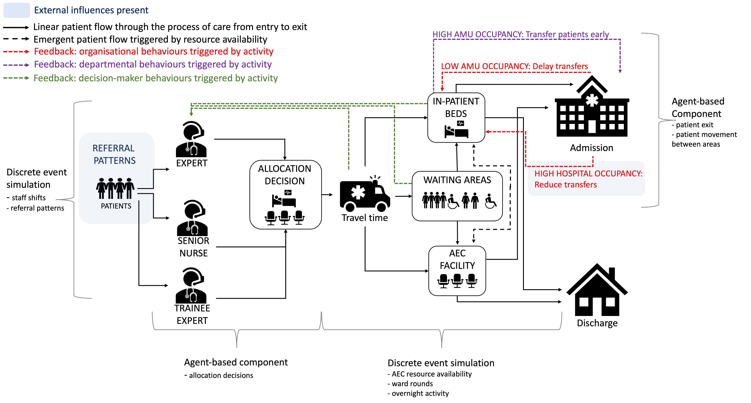
Fig. 1 Overview of behaviours and feedback

Entities, state variables, and scales
Entities are patients, decision-makers, decision patches, and the wider hospital system. Their state variables are described in Table 1

Table 1 Decision-maker, patch, and global state variables
VARIABLE | DESCRIPTION | FORMAT; NATURE; RANGE
DECISION-MAKERS
expert-adjust | Proportion of patients that a decision-maker deems AEC-suitable relative to population prevalence of AEC conditions | Rational number; static; 0.0 – 3.8
max-AEC-risk | Additional proportion of patients allocated to AEC when overcrowding is sensed. | Rational number; static; 0.0 – 0.15
DECISION-PATCHES
high-risk-adjust | Variable that allows a patch to adopt the max-AEC-risk profile of any decision-maker on that patch | Rational number; static; 0.0 – 0.15
expert-adjust-local | Variable that allows a patch to adopt the expert-adjust value of any decision-maker on that patch | Rational number; static; 0.0 – 3.8
PATIENTS
condition | Variable representing probability of an individual patient’s condition being suitable for AEC | Integer; static; 0 - 1 uniform distribution
AEC-ok? | Variable that indicates suitability to attend the AEC area for care | Logical; static; true/false
ed | Variable indicating if patient has been referred from the emergency department | Logical; static; true/false
expert-dm | Variable indicating if the allocating decision-maker was a consultant or not | Logical; static; true/false
aec-possible | Variable indicating if patient arrived during AEC opening hours | Logical; static; true/false
treatment_started | Variable indicated when patient started receiving care | Integer; static; >0 (model ticks)
treatment_time | Variable indicating time required to undergo investigation and care according to area and initial for-discharge value | Integer; static; 30-2150 (model ticks)
los | Variable indicating model time spent in the department from arrival to model exit | Integer; dynamic; >0 (model ticks)
delayed | Variable indicating model time spent in waiting to start treatment | Integer; dynamic >0 (model ticks)
time_complete | Variable indicating model time when care expected to finish | Integer; dynamic >0 (model ticks)
complete? | Variable indicating if patients is ready to leave the area | Logical; dynamic; true/false
for-discharge | Variable indicating route of exit from the model | Logical; dynamic; true/false
final-area | Variable indicating area where care was predominantly received | Binary; dynamic; 0 or 1
 | GLOBAL VARIABLES
amu-crowding | Variable indicating the AMU-bedded occupancy tolerance until early moves and increased AEC allocations are triggered | Integer; dynamic; 50 – 185%
capacity-threshold | Minimum number of available AMU in-patient beds per patient expected allocated to a bed but not arrived before early transfer of patients is initiated | Integer; static;  ≤65 referrals = 10  >65 referrals = 15  Overnight = 2
aec-admits | Proportion of AEC-patients who exit decision changes from admission to discharge upon care completion | Rational; dynamic; 0.10 – 0.40
discharge-amu | Proportion of in-patients who exit decision changes from admission to discharge upon care completion | Rational; dynamic; 0.075 – 0.20
peak | Variable indicating peak activity for referrals | Logical; dynamic; true/false
so-far | Daily running tally of patients referred into the department | Integer; dynamic >0
refused | Daily running tally of patients advised not to attend | Integer; dynamic >0
to-come-in | Daily running tally of patients travelling to department | Integer; dynamic >0
mean_demand | mean number of patients to be referred over 24hrs | Integer; dynamic >0

The landscape is the urgent care environment consisting of 11 x 11 square patches (Figure 2). There is a block of 15 patches labelled ‘Ambulatory Assessment Area’ representing AEC-care and block of 31 patches representing labelled ‘Bedded Area Bays’ which represent AMU-care. There is also a block of 18 patches for the bedded waiting area (waiting-bedded) that run along the area between the bedded are bays and the bathroom & kitchen block. Four patches representing the AEC-care waiting area (waiting-aec) lie between the ambulatory assessment are and the bathroom and kitchen block. There is a patch for entry the unit from each source (not visible) and three patches to represent patients pending who are travelling to or waiting to be transferred to the unit (under the ‘To come in’ monitors. There are three decision patches where decision-makers position themselves to receive patients when in shift.

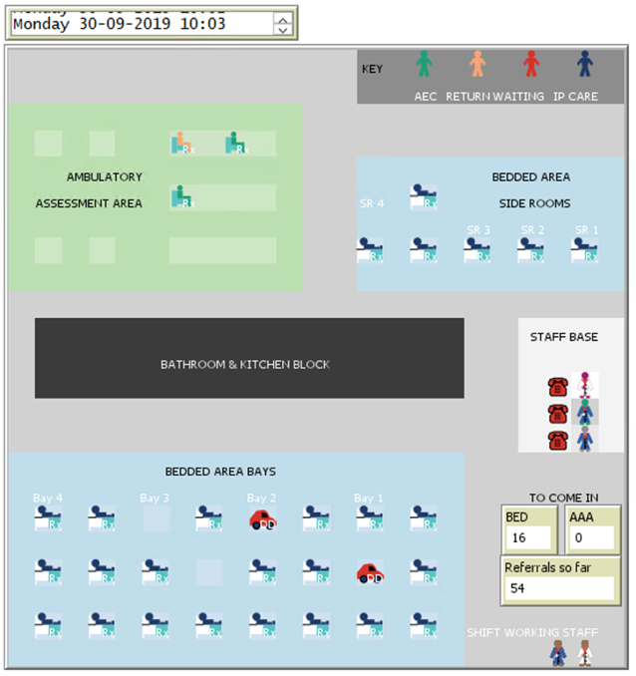
AEC: Ambulatory emergency care
AAA: Ambulatory assessment area

Fig. 2 Screenshot of the model landscape
Ambulatory emergency care is called the ambulatory assessment area on the study site. The bedded area contains four six-bedded bays. The pool of staff working in shifts are visible in the lower right-hand corner along with the number of patients allocated to bedded and ambulatory care. Staff next to the telephones at the staff base are those actively performing decision-maker duties. The key identifies to type of patient present in the unit and the time. Date and time are anchored to the model ticks.

The model tick counter is anchored to time and set to start on Monday 30th September at 00:00. Each time step is one minute, and simulations run for 181441 time-steps representing 18 weeks of ward activity (inclusive of 2-week model warm-up period). This is assumed to be sufficient time to identify recurring patterns in activity representative of year-round activity. The model uses model ticks to identify and execute scheduled events before updating the model time expected for the next event (e.g., peak-start set for 1000hrs on the first day when be executed at 600 model ticks and then be updated to be executed at 1000hrs the following day by updating peak-start occur at 2040 ticks).

Process overview and scheduling

Schedule

set-demand
If 0000hrs sensed, daily departmental outputs and global variables that accumulate the daily tallies of patient activity are set to zero. Updates mean_demand according whether or not it is a weekend or weekday. The capacity-threshold variable is also set according to the previous 24hrs total referral numbers.

start-work
Any DMs situated on a decision patch (one per patch) indicate their decision-maker type and that they are available to newly referred patients. Patches with no DMs are instructed to indicate non-availability.

shift-work
If end of shift time for trainee-expert and/or expert is reached, the DM occupying a decision-patch is asked to move to the staff pool area. If start of shift time for trainee-expert and/or expert is reached, a member of staff from that group is chosen at random to move to an available decision-patch to start allocating. If full-time trainees are selected to work by the user in the GUI, the next model time for shift changes is updated (shift-change-am; shift-change-pm)

resource-shifts
The procedure adjusts resources and patient movement according to presence/absence of the overnight period.
- At first detection of overnight-end (of night shift), the start of the next day’s night shift is set (overnight-start) according to overnight-duration plus 24hrs. If night-shift has/has not ended: aec-available is set to true/false. capacity-threshold is set to two until overnight period ends.
- When overnight detected: AEC-care patients are relocated to any available AMU-care if >120mins of treatment left to complete (update variables to identify as AMU-bedded patients). If <120mins left they remain on AEC-care.
- If unoccupied AMU-care ≥ sufficient-beds-to-cope-day (or sufficient-beds-to-cope-night):2mins are added to the time_complete variable of all patients with for-discharge = false at every time step until unoccupied AMU-care < sufficient-beds-to-cope-day/night. While AMU-care ≥ sufficient-beds-to-cope-day/night, the sub-model avoid-overnight-moves runs.
- Patients anticipated to complete care within the first hour of the morning senior review have a delay added to their to time_complete variable from a reporter (normal distribution - mean 300mins; sd 180mins). If < 3 patients expected to AMU-care and >0 unoccupied AMU-care, patients with early-move = true update to false and their time_complete variable is updated from a reporter (normal distribution - mean 300mins; sd 180mins).

patients-referred
This procedure creates new patients from ED and non-ED sources, and AEC-returns patients. New patients enter the model via a sub-model Rate of arrivals. Upon creation patients are assigned their variable condition and ed is set to true/false according to referral source. complete? is set to false. Los and time_in_system are set to zero, patients update label as ‘call waiting’ and moved to a queue awaiting allocation. The state variable so-far is updated by one for each patient creation.

The rate of AEC-return patients (Poisson distribution) for the day is determined by a random uniform distribution draw divided by the duration of the AEC return clinic set at initiation. AEC-return patients update label as ‘return’ and AEC-ok? = true and for-discharge = true. They are assigned a random individual treatment-time from a reporter to be no longer than the clinic duration.

present
This procedure instructs patients to move, at random, to an available DM (no other patients on the patch). Patient with ed = false default to an expert DMs if available, followed by trainee, then nurse. Patients with ed = true prefer a nurse DM, followed by a trainee, then an expert. Patients update their variable expert-dm = true if the DM is an expert false otherwise. DMs can only allocate one patient at a time, but multiple DMs can allocate simultaneously.

decide
This procedure allocates patients to areas for care using the allocate and adjust sub-models. If a patient presents to an expert and non-attendance is sensed (condition ≥ non-urgent) the patient exits the model, and the global variable refused is updated by 1.

Trainee and nurse DMs only ever decide using the allocate procedure. Expert DMs perform the allocate procedure when there is no overcrowding and adjust procedure if they sense overcrowding. Overcrowding is sensed in one of two ways:
- patients currently occupying waiting-bedded ≥ max-ip-waits
- patients allocated to AMU-care currently occupying to-come-in ≥ max-expects-trigger

If both conditions are met the adjust procedure is unaltered. In both the allocate and adjust procedures, AEC-ok?, treatment_time, time_referred, for-discharge, and time_arrived are updated. Patients then move to the to-come-in patch and are labelled according to their allocation. to-come-in queues are updated in the GUI.

get-treatment
All patient collectives in the model update individual los (model time since arrival onto the department) and time-in-system (model time since referral) excluding those on the to-come-in patch who only update their time-in-system variable.
Patient variables are update according to their current state:
- Patients on to-come-in:
Compare their time_arrived with current model time. When time_arrived = ticks, follow the sub-model relocate
Update their aec-possible = true/false to mirror aec-available = true/false

- Patients on waiting-bedded or waiting-aec:
If los < waiting-time then follow the wait-for-resource sub-model, otherwise follow the skip-queue sub-model

- Patients on AMU-care and AEC-care update label to identify treatment started, update their final-area variable to reflect where they are: 0 (AMU-care) or 1 (AEC-care). Patients moved to AEC-care awaiting transport home update final-area = 0

- Patients on AMU-care with label = ‘delayed discharge’ move to AEC-care if aec-available = true and overcrowding is sensed (set aec-move = true)

- Patients on AEC-care and AMU-care with complete? = false: compare their variable time_complete with current model time. Update variables as follows:
0800-0300hrs
Once time_complete = ticks if not for early transfer, update their for-discharge variable as follows:
AMU-care patients identified as for-discharge = false: If random-uniform 1.0 < discharge-amu they change for-discharge = true and set complete? = true.
AEC-care patients with for-discharge = true: If random-uniform 1.0 < aec-admit update for-discharge = false and set complete? = true.

0300hrs - 0800hrs
If time_complete = ticks and AEC-ok? = true: if reporter (0-1) < aec-admit update for-discharge = false and set complete? = true.
If time_complete = ticks and AEC-ok? = false and for-discharge = true, update label to ‘delayed discharge’, update time_complete = overnight-end plus reporter value between 60-360.
If time_complete = ticks and AEC-ok? = false and for-discharge = false: if reported (0-1) < discharge-amu update for-discharge = true and set complete? = true

All patients with complete? = true undergo the dispose sub-model

readjust-location
Any patients on AEC-care with AEC-ok? = false move to any unoccupied AMU-care at random. Update variables to identify as AMU-care (shape, colour). Variable update delayed = los at the moment of relocation. If delayed <5 it is updated to zero.

leave
The procedure instructs patients who have undergone the dispose procedure to undergo the exit-model sub-model. Updates unique patients outcomes for model outputs listed above identifying via label (AECH, AECT, AMUH, AMUT) plus hrqol (from a reporter), and experience according to los, place of care, and delayed via lists. May also collect data on arrival, departure times as required.

update
If ticks = peak-start, the start-peak sub-model is initiated. This sub-model sets peak = true until ticks = peak-end when peak is set to false. peak-start, peak-end are updated according to current model time and peak-duration. If 0000hrs is sensed, daily departmental outputs updated and stored in .csv file. Daily values are only stored after a two-week warm-up period.

amu-discharge and aec-admit are as set for the next 24hrs via reporters. If previous day’s attendances >65 amu-crowding is set to (amu-crowding-tolerance + 10), otherwise amu-crowding = amu-crowding-tolerance.

redirect
This procedure provides a safety net to prevent the model from crashing in event of extreme over-crowding. If there is no patients space available anywhere (clinical and waiting), patients exit the model. This will repeat on every tick until capacity anywhere in model >0. This procedure also triggers the sub-model system-crowding-reaction when overcrowding is sensed (early transfers from AMU-care identified)

Outputs
Primary (collated at end of model run)
- Tally of ‘true/false AEC’ and ‘true/false AMU’ patients per day according to los, for-discharge, and final-area
- Total daily attendances in each area
- Total number of patients allocated to each area
- Total discharges from each area
- Total discharges within 24hrs
- Total admissions into the hospital from each area
- Total number of patients moved in the out-of-hours period
- Total number of patients placed in the waiting-bedded area
- Cumulative health index for each area
- Proportion of patients with a positive experience
- Total number of patients starting care in their non-allocated area
- Total number of patients refused attendance (by expert-DM)
- System failure events

Secondary (stored as lists during model run)
- Individual health index for all discharged patients
- Area that care was delivered prior to completion
- Individual patient length of stay (all patients)
- Individual delay to starting treatment (all patients)
- Occupancy levels for each area at each tick

Design concepts

Basic principles
Behaviours are modelled to follow three aims:
- Limit overcrowding
  - Experts increase AEC allocations in response to environmental feedback provided their Max-AEC-risk variable is >0
  - Patients will complete care early, move within the model, or transfer their for-discharge status to reproduce the organisational behaviours to create capacity
- Limit waste – the system automatically avoids large numbers of empty beds in AMU
- Prevent inefficiencies in other areas of the hospital via:
  - Tolerating overcrowding
  - Limiting transfer of patients from 0300-0800hrs when system resources are reduced

Emergence
Efficiency outcomes of occupancy, delays, overnight moves, and hospital admissions emerge as allocation decisions at referral create or mitigate queues of patients. These queues delay access allocated resources and treatment, increasing overall lengths of stay. Tolerance of overcrowding provides time for patients to complete care and realise discharge whereas forced early movement to create capacity risks increased admissions as patients do not undergo a final disposition review (default to for-discharge = false)

Patients’ health change on discharge (hrqol) is determined by final-area, e.g., if allocated to AEC but moved to AMU-bedded to complete care they will reflect an AMU-related health change. Patient experience is directly influenced by delays to starting care and time spent in the AEC area receiving care (not time spent in AMU-bedded). These emerge as a result of queues from allocation decisions and tolerance of crowding.

System behaviours (reproduced by patients variables and logic) are outside of the control of other agents in the model. DMs only control their own allocation decisions

Adaption
In periods of inefficiency, expert DM agents adapt their allocation decision directly in response to patterns of actual or anticipated crowding. Patients adapt their time to complete care (reduced) if overcrowding sensed/anticipated. Patients will alter their discharge status, care completion time, and/or location in response to overcrowding.

Objectives
No direct-objective seeking is built into the model.

Learning
No learning is built into the model.

Prediction
Decision-makers explicitly predict the type of care required for each patient which assumes their discharge potential according to their condition based and the DM’s level of expertise. This occurs in real life clinician-to-clinician referral as patient-specific and system capacity information is available to DMs.

Sensing
Expert DMs sense the condition of the patient, the source of referral, and the prevalence of AEC in the source populations. They also sense the number of patients waiting for AMU-care and the number allocated-still-expected to AMU-care. The decision-maker does not sense that the system has failed.

Patients are programmed to sense the variables that influence hospital system behaviours in managing the flow of patients. This reproduces how the hospital staff and managerial teams alter patient movement in response to the environment:
- the number of expected patients and current in-patient capacity
- the demand upon the hospital over the previous day (system capacity for admissions)
- the overcrowding tolerance level and the number of beds needed to mitigate wasteful use of AMU resources
- care completion, discharge, and delay statuses of themselves and all other patients, the availability of AEC facilities, and the timing of scheduled events (e.g. ward rounds)

Interaction
Decision-makers interact with patients by allocating them to their resource for care.
Patients interact indirectly as they compete for decision-makers to allocate, departmental resources, and early transferring.

Stochasticity
Patient arrival rate is stochastic and drawn from a Poisson distribution. Time for patients to arrive on to the unit is taken from a random-normal distribution that accounts for UK government standards for ED transfer time (as of 2022), observed variation in arrival from different parts of the region, and different modes of transport (e.g., private versus ambulance).

condition and treatment_time are randomly assigned from distributions as shown in Tables 1 and 3. This reproduces the wide variation of clinical pathologies and patient needs experienced on the case study site. Although for-discharge is initially determined by the patient condition and prevalence of AEC suitability, stochasticity is added at the end of their treatment time to represent unanticipated results and/or subsequent health decline. Health change is taken from a random normal distribution according to area of care at completion informed by prospective data collection on the case study site (EQ5D5L informed health utility <4hrs after arrival and up 30days post-discharge). Orders of patient movement are random except where patients have been waiting ≥1hrs for a bedded resource or any area for ≥4hrs.

Collectives
Patient collectives emerge throughout model runs. Collectives that emerge upon arrival compete for DM time to be allocated and for the different resource areas (upon arrival and once care complete). Return AEC patients compete for AEC and waiting area resources only. The presence of bedded waiting area collectives and anticipated AMU-care patients encourages the decision-maker agents to increase allocation to AEC resources and patients to complete care early (reproducing organisational behaviours to expedite care plans). Patients do not respond to delays or collectives in AEC beyond model exit when capacity is zero.

Observation
Occupancy, daily waits, admissions and system failure events are updated continuously and displayed in the graphic user interface (GUI). GUI also displays the number of patients expected in each area, the type of care they are undergoing (according to colour-code), and the number of referrals waiting to be answered. Individual patient outputs are stored in csv. file format. Data informing the occupancy plot on the GUI is collected in a csv. file at the end of model run. The view shows the position of each patient in the urgent care landscape.
Plots display:
- Bar chart of daily AMU-care waits (≥5mins waiting)
- Occupancy in each area of care
- proportion of patient admitted per day (of those completing care)
Monitors display:
- Referral calls waiting to be answered
- Anticipated AMU and AEC patients
- Total referrals so far that day
- System failure events
- Patients placed in AEC-care due to long waits
- Patient starting care in their non-allocated (wrong) place
- Patient advised for non-attendance
- Patients transferred overnight

There is a fixed output window to display the day, date, and time to orientate users as they interact with the model (requires time extension to NetLogo software).

Initialisation
Upon clicking ‘Initiate model set up’, the environment is set up and three user prompts appear:

“Set demand parameters, prevalence of out-patient (AEC) suitability according to local population, choose staffing configuration”
“'INITIATE MODEL SET-UP' button will reset choices in case of error”
“Once selections complete click 'SET PARAMETERS' and 'START/STOP' to run the model”

Default settings exist for all inputs decision-maker staff to allocate. User selects the number, start/end shift times, and type of staff to work – full-time (all staff options), or shifts (experts and trainee-experts only). They are reminded to select additional staff if they wish to mix expertise. Changes to settings at initialisation will not be saved unless ‘Set parameters’ button is clicked. The model may be start/stop the model as required after this point. If no staff are selected, the model will still run but no patients will arrive (except AEC returns as they are not allocated).

Table 2 Variable and parameter values at initialisation and sensitivity analysis ranges
Variable | Description | Value | GUI | Sensitivity analysis | Source
expert-rota-staffing | Number of consultants rotating through shifts | 15 | Yes | n/a | MA
trainee-rota-staffing | Number of trainees rotating through shifts | 30 | Yes | n/a | MA
shift-change-am | Fixed shift changes for full-time trainees | 8 | No | n/a | HDS
shift-change-pm | Fixed shift changes for full-time trainees | 20 | No | n/a | HDS
non-urgent | Patient conditions refused at referrals | 0.96 | No | 0.96 – 1.0 | MA
ed-aec-prev | Conditions with potential for AEC in ED population | 0.067 | Yes | 0.05 – 0.25 | Expert opinion & HDS
noned-aec-prev | Conditions with potential for AEC in non-ED population | 0.213 | Yes | 0.15 – 0.40 | Expert opinion & HDS
peak-split | Proportion of ED patients arriving during peak hours | 0.20 | No | n/a | HDS
off-peak-split | Proportion of ED patients arriving during off-peak hours | 0.50 | No | n/a | HDS
peak-demand | Proportion of all patients arriving during peak hours | 0.6 | No | n/a | HDS
Overnight-transfer-duration | Period of time accepted for transfer of patients overnight | 240mins | No | n/a | MA
slow-overnight-arrivals | Model time to represent 0300hrs | 1620 | No | n/a | MA
Open_AEC | Opening time of AEC facilities | 8 | Yes | n/a | MA
Close_AEC | Closing time of AEC facilities | 23 | Yes | n/a | MA
aec-returns-end | 1600hrs finish | 960 | No | n/a | MA
overnight-start | Model time for start of overnight period | Open_AEC | No | n/a | MA & HDS
overnight-end | Model time for end of overnight period | Close_AEC | No | n/a | MA & HDS
max-ip-waits | Max number on waiting-bedded that triggers overcrowding response | 3 | No |  | MA
Max-expects-trigger | Max number of expected AMU-care patients that triggers capacity creation behaviours | 8 | No |  | MA
waiting-time | Delay tolerated by patients in waiting-bedded before actively seeking to start care in any area | 60mins | No | n/a | MA
sufficient-beds-to-cope-night | Number of available AMU-resources that triggers a delay in transfer of patients at night | 6 | No | n/a | MA
sufficient-beds-to-cope-day | Number of available AMU-resources that triggers a delay in transfer of patients during day | 6 | No | n/a | MA
peak-start | Start of high volume of referrals | 9 | Yes | n/a | HDS
peak-end | End of high volume of referrals | 18 | Yes | n/a | HDS
aec-admits | AEC admission upon care completion | 0.10 | No | 0.0 – 0.5 | MA & HDS
discharge-amu | AMU Bedded discharge upon care completion | 0.075 | No | 0.0 – 0.5 | MA & HDS
Mean_weekday_attendances | Mean number of referrals Monday-Friday. | 45 | Yes | 43.0 – 50.0 | MA & HDS
Mean_weekend_attendances | Mean number of referrals Saturday and Sunday. | 35 | Yes | n/a | MA & HDS
amu-crowding | Occupancy tolerance | 110 | Yes | 90 – 150 | MA
capacity-threshold | AMU-bedded expects per available bed | 10 | No | 5 – 20 Uniform | MA
MA - Modeller assumptions based on Ethnographic case study; HDS – Historical dataset
n/a indicated parameters with no monotonic relationship or no uncertainty in source (e.g. time-of-day)
All sensitivity analyses used uniform distribution as no available data to inform and high stochasticity

Input data
There are no input data

Sub-models
Small sub-models have been described in the relevant procedure in the schedule section. Here, more complicated sub-models are explained in flow diagrams with relevant reporters tabulated.

Rate of arrivals
The model senses high demand periods via peak = true or false. When peak = false, if the period of slow arrivals is sensed, the rate is halved. For all scenarios:
mean-demand = Mean_weekday_attendances (or Mean_weekend_attendances if weekend sensed) * 0.75
Multiplication by a factor of 0.75 is required to prevent unnaturally large volumes of referrals that occurs as a feature of the demand rate requiring separation into three different time periods. This allows the user interface selection of Mean_weekend_attendances and Mean_weekday_attendances to reflect activity seen in real-life creating a meaningful interaction with the model as the input value can directly relate to their day-to-day activity. Rate is calculated as follows:

peak = true:
ED source rate =
(mean-demand * peak-demand * peak-split) / duration of peak
Non-ED source rate =
(mean-demand * peak-demand * (1 - peak-split)) / duration of peak

peak = false & slow-arrivals = false:
ED source rate =
(mean-demand * (1 - peak-demand) * off-peak-split )/ duration of off-peak
Non-ED source rate =
(mean-demand * (1 - peak-demand) * (1 – off-peak-split))/ duration of off-peak

peak = false & slow-arrivals = true:
ED source rate =
(mean-demand * (1 - peak-demand) * off-peak-split)/ (duration of off-peak * 2)
Non-ED source rate =
(mean-demand * (1 - peak-demand) * (1 – off-peak-split))/ (duration of off-peak * 2)

avoid-overnight-moves
Sub-model is shown in Figure 3. Delays are modeller assumptions based on the ethnographic study.
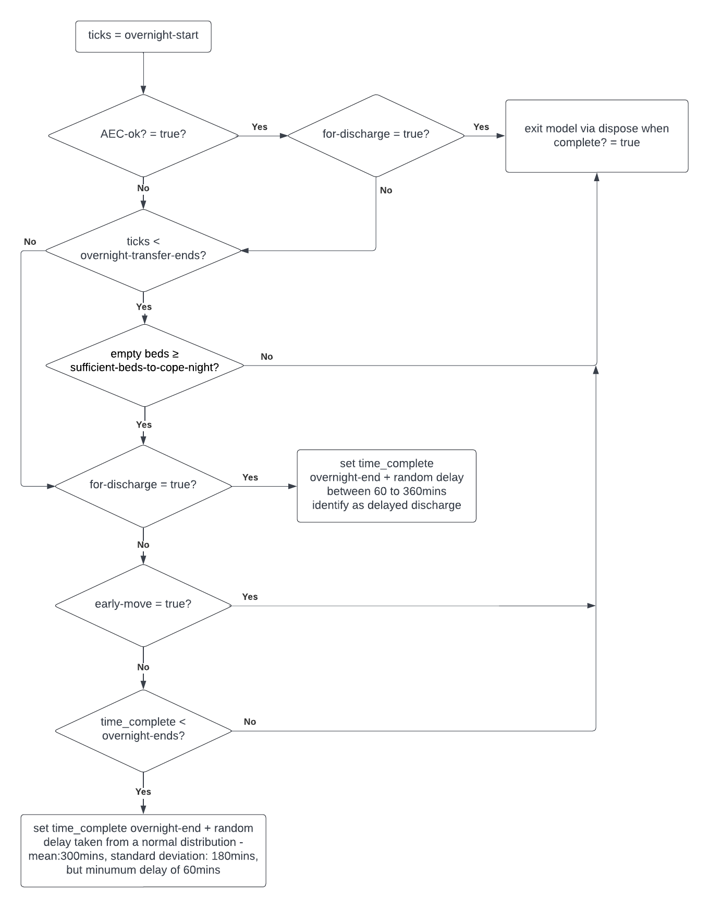
Figure 3 avoid-overnight-moves

allocate and adjust procedures
The logic for allocate and adjust is shown in Figure 4 with reporters in Table 3
Table 3 Variables, parameters and reporters used in allocation decisions
Parameter | Type | Description | Values | Source
AEC-ok? | Logical  Static | Suitability for ambulatory care | Allocate reports true if:  condition ≤ expert-adjust-local = true and aec-available = true  Adjust reports true if:  Condition ≤ expert-adjust-local + high-risk-adjust = true and aec-available = true | Ethnographic observation and modeller assumptions
time_arrived  (ticks) | Rational Number | Non-ED patients travel time | If AEC-ok? = true then samples from random gamma distribution: $α=2 β=0.045$  If AEC-ok? = false then randomly samples from distribution according to time:  0800-2300hrs:  - gamma distribution $α=11 β=0.08$  2301-0759hrs:  - gamma distribution $α=6 β=0.06$  In all cases resamples if reports <5mins | Ethnographic observation and modeller assumptions. Assumes travel to department is longer during peak and AEC-care patients use private transport (quick)
 | Rational Number | ED patients travel time | Randomly samples from distribution according to presence/absence of peak  Peak = true:  - normal distribution $mean=90 sd=45$  Peak = false:  - normal distribution $mean=60 sd=30$  In all cases resamples if reports <0mins | Ethnographic observation and modeller assumptions. Assumes arrivals take longer during working hours.
treatment_time  (ticks) | Rational Number | AEC-care discharges | Random sample from gamma distribution $α=4.5 β=0.02$ | Historical case site dataset October 2019  and modeller assumptions
 |  | AEC-care admissions | Random sample from gamma distribution $α=24 β=0.04$
 |  | AMU-care discharges | Random sample from gamma distribution $α=24 β=0.04$
 |  | AMU-care admissions | Random sample from gamma distribution $α=3 β=0.008$
Expert-adjust | Rational Number; static | experts | Gamma distribution ($α$8, $β$ 6.9)  Truncated at 0.5  (sensitivity analysis on $α$ value: 5.0 – 10.0, uniform) | Ethnographic observation and modeller assumptions
 |  | trainees | Normal distribution mean 0.0 sd 0.1  Truncated from 0.2 – 0.5  (sensitivity analysis on mean: -1.0 – 2.0, uniform)
 |  | nurses | Uniform distribution 0.0-0.1  (sensitivity analysis on mean: 0.025 – 0.20, uniform)
Max-AEC _risk | Rational Number; static | experts | Overcrowding response: Random uniform:  0.05 – 0.15  No overcrowding response: 0.0
 |  | trainees & nurses | 0.0

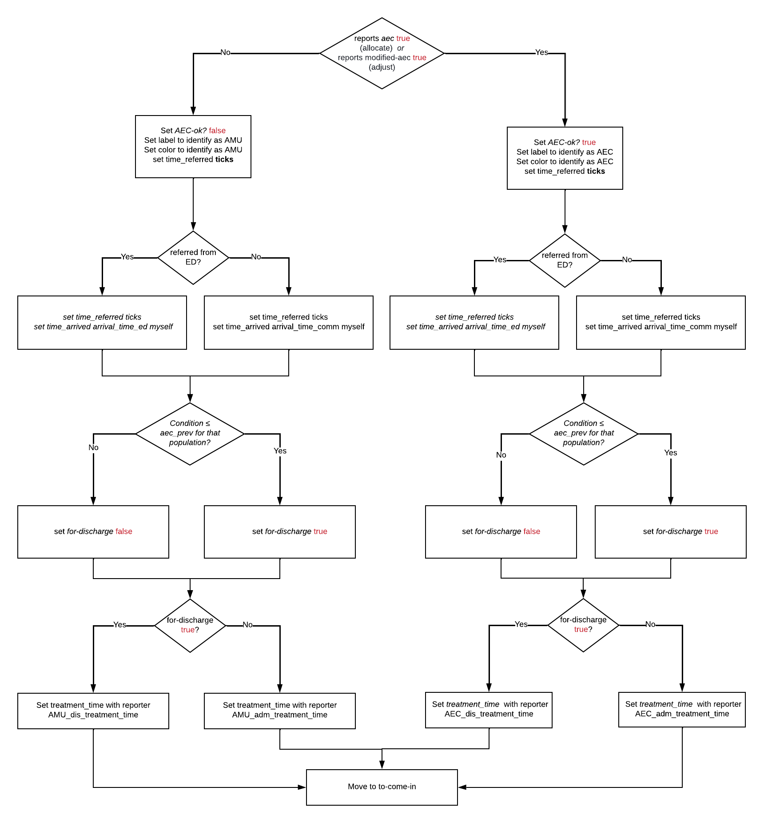
Figure 4 Sub-models to allocate and adjust

relocate
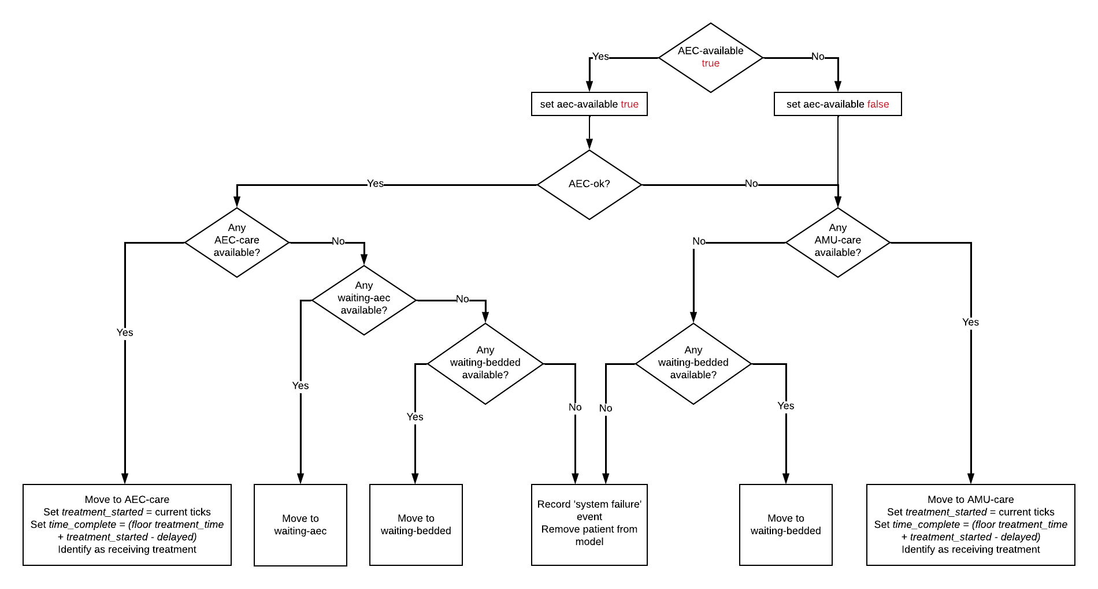
Figure 5 Sub-model to relocate
Note when AEC-care is closed all patients default to AMU-care but those allocated to AEC-care at referral retain their AEC-ok = true status.

wait-for-resource & skip-queue in AEC-waiting
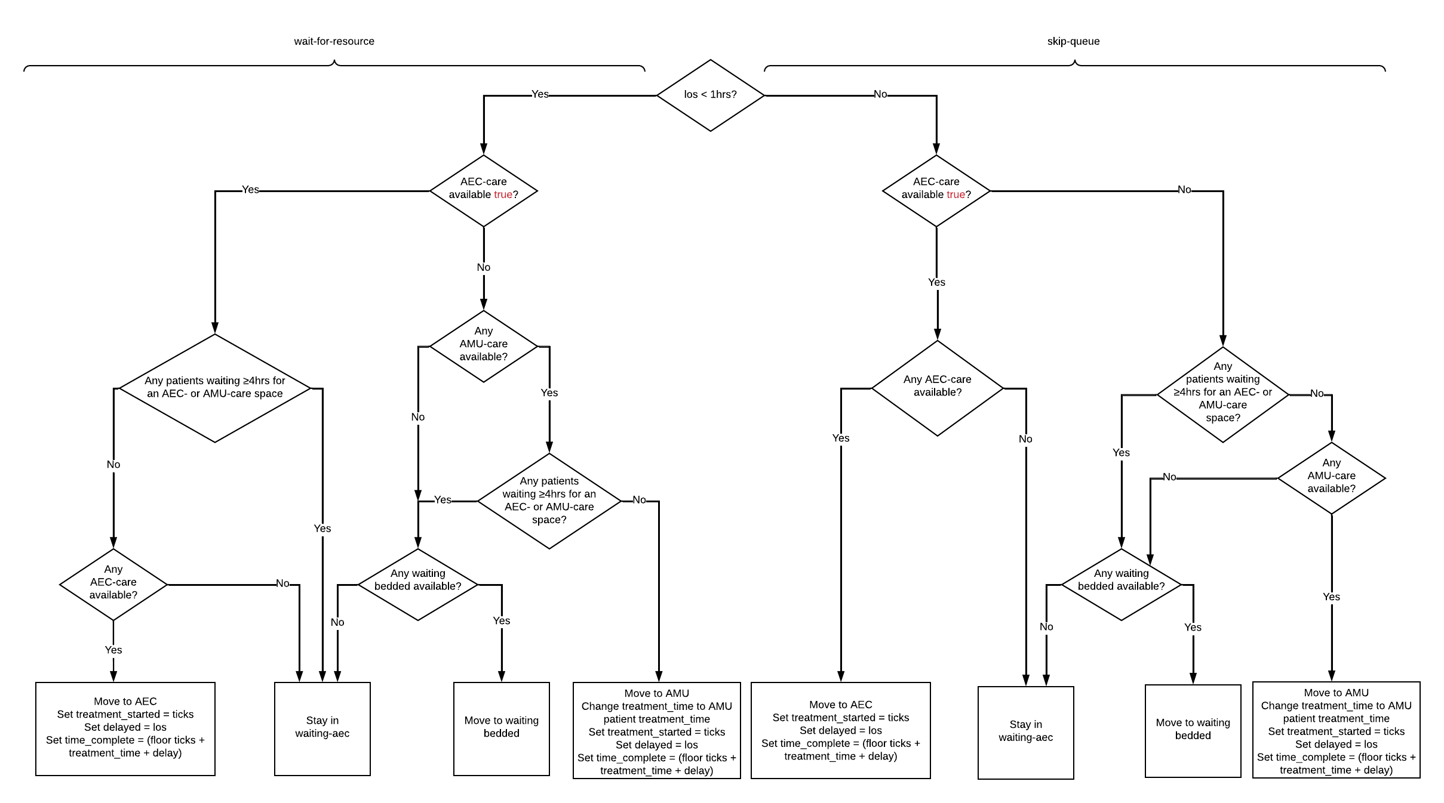
Figure 6 Sub-models wait-for-resource and skip-queue for patient in AEC-waiting
Patients will preferentially move to AEC-care spaces when available, but will seek any space if waiting >1hr provided no patients have been waiting longer than 4hrs

wait-for-resource & skip-queue in Bedded-waiting
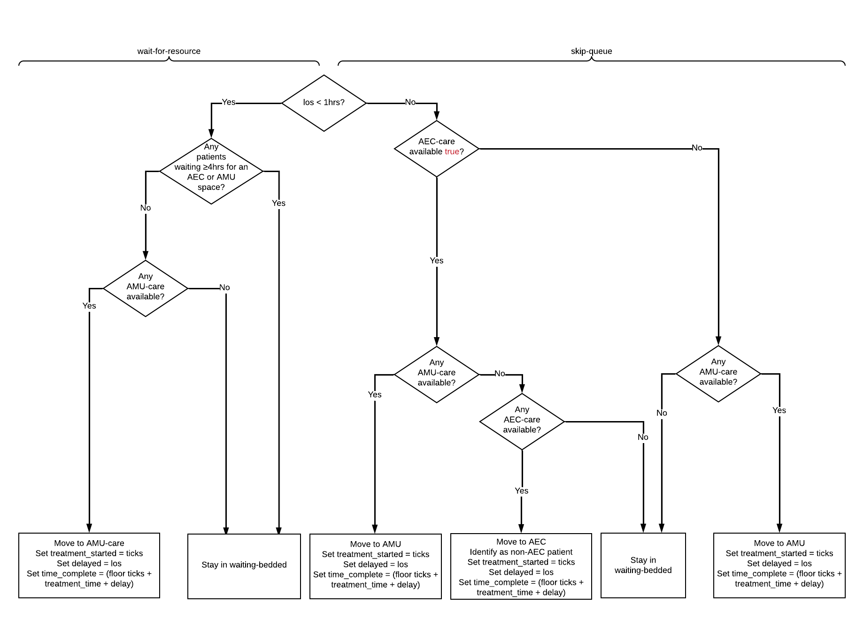
Figure 7 Sub-models wait-for-resource and skip-queue for patient in Bedded-waiting
Patients will preferentially move to AMU-care spaces when available, but will seek any space if waiting >1hr provided no patients have been waiting longer than 4hrs

Dispose
Only patients identified as complete undergo. Sub-model to collect daily tallies of patients discharged within 24hrs, patients discharged (all areas), patients admitted (all areas), and daily tally of patients completing care in each area for analyses (not performed in the model). Asks patients to identify as ready for home or transfer for the leave procedure. Also determines health change and experience for each patient as shown in Table 4.
Table 4 Parameters used in dispose procedure
Variable | Description | Type | Patient group | Values | Source
hrqol  (for-discharge = true patients only) | Health change | Rational number | AEC-care | Random normal distribution  mean 0.068 sd 0.117 | Distribution created from locally collected data using EQ5D5L survey
 |  |  | AMU-care | Random-normal distribution  mean 0.111 sd 0.131
exp-daily-aec | Experience | Integer | AEC-ok? true | $$\left\{\begin{aligned}1=default \\ 0=los ≥480mins \\ 0=delayed ≥240mins\end{aligned}\right.$$ | Ethnographic observation, experience survey (locally collected), and modeller assumptions
exp-daily-amu | Experience | Integer | AEC-ok? false | $$\left\{\begin{aligned}1=default \\ 0=delayed ≥60mins\end{aligned}\right.$$

exit-model
A global (daily) tally of ED and noned patients is updated.
A global (daily) tally of patients transferred between Close_AEC and Open_AEC is updated.
A global tally of patients transferred to a hospital bed during out-of-hours period (aec-available = false) is updated
A global (daily) tally of the outcomes of expert and non-expert DMs is updated using the decision-logic shown in Figure 8

If the model is still in the warm-up period, patients are removed. After warm-patient variable listed as model outputs are stored

system-crowding-reaction
Procedure to create urgent care capacity when overcrowding sensed by the hospital system (observer). See Figure 9 This procedure is triggered if overcrowding is present or if the ratio of expected AMU-bed patients to currently available beds ≥ expected-to-current-capacity-ratio. expected-to-current-capacity-ratio is determined in the set-demand procedure This reflects the variation in hospital capacity to accommodate early moves from the AMU when recent demand has been high. The model will only accept ≤ 3 early-moves at any time.

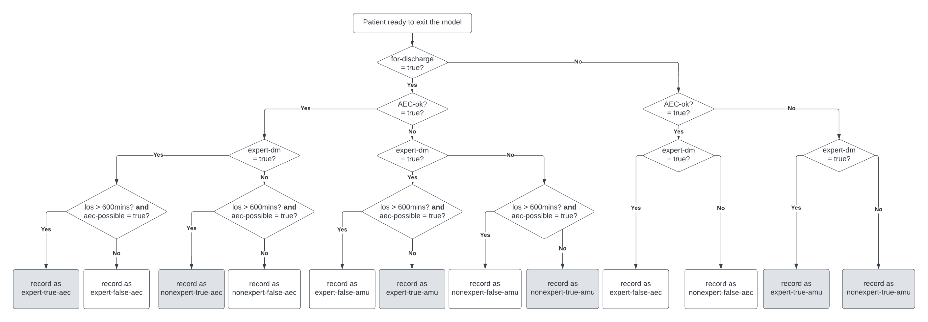
Figure 8 Logic for collecting outcomes of expert and non-expert allocation decisions
Data is tallied daily and presented in the final model output for sensitivity and specificity analysis
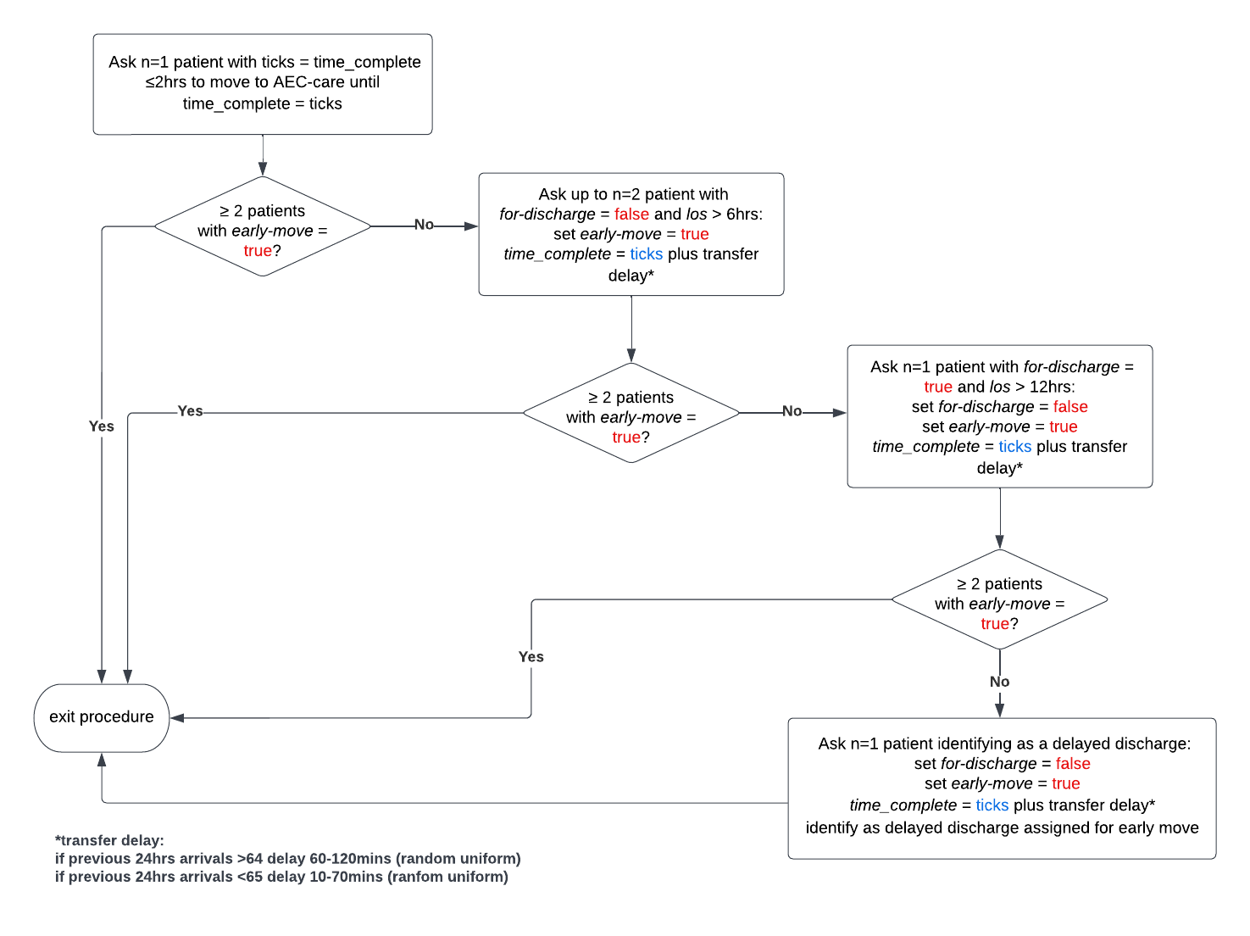
Figure 9 system-crowding-reaction

